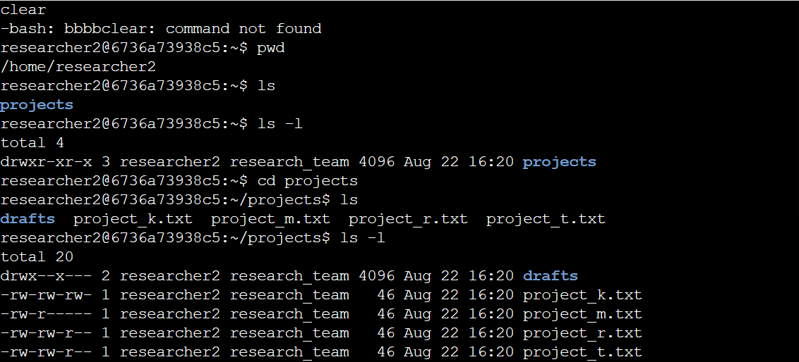The Permission string in Linux for directory and files.

Directory/File permission strings.

On the first set of 10 letters and the dash on the left side, you seeing (drwxrwxrwx -), are called permission strings or codes the this give mean on specific rights and individual have on a directory or file in a directory, each of them have a meaning.

**d** means directory, always at the beginning of the string for directory permission,

**-** alone indicate for files in a directory,

Then you repeated the letter rwx on 3x this indicates the individual person or group privilege status, first one being the o that owner the file **-** or **d** directory, privilege rwx r=read, w=write x=execute, second users=u and group=g o=rwx u=rwx g=rwx and can be o=r-x u=-rw- g=-r-x

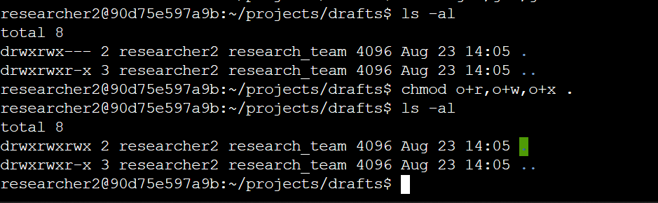

Read: can read the document, w=write on it, x= can execute such delete, edit this privilege most time is always for the owner of file or directory.

This can be change according to how sensitive file or directory by using the initiating command Chmod eg drwx or -rwxrwxrwx or rw-r--r—- or rw-rw-rw- etc

Sample command line can be Chmod o+x, u+r, g+w .projects if observed you will see comas and plus sign, as well (.) which indicates a hidden file or directory its define the

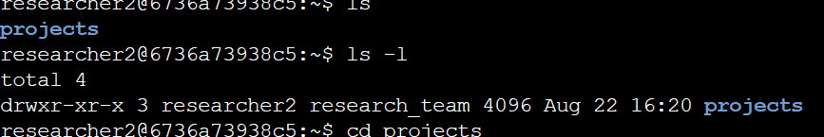

rights giving at the privilege stages. The ( .Projects) is the name of they for the file or directory the,

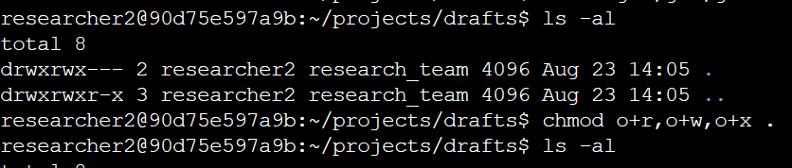

you'll likely handle directory and file permissions. Employ 'ls -l' and 'ls -la' to explore permissions. Leverage 'chmod' to adjust user permissions, aligning with the principle of least privilege.